**DAILY ONLINE ACTIVITIES SUMMARY**

|  |  |  |  |  |  |  |  |
| --- | --- | --- | --- | --- | --- | --- | --- |
| **Date:** | **07/06/2020** | | | | **Name:** | **Churashma** | |
| **Sem & Sec** | **4th SEM 'A' Section** | | | | **USN:** | **4AL18CS019** | |
| **Online Test Summary** | | | | | | | |
| **Subject** | | **No test** | | | | | |
| **Max. Marks** | | **-** | | **Score** | | **-** | |
| **Certification Course Summary** | | | | | | | |
| **Course** | **Introduction to ethical hacking** | | | | | | |
| **Certificate Provider** | | | **greatlearning academy** | **Duration** | | | **4.5 hours** |
| **Coding Challenges** | | | | | | | |
| **Problem statement 1:**  Write a C++ Program to swap two numbers using friend as a bridge concept. | | | | | | | |
| **Status: completed** | | | | | | | |
| **Uploaded the report in Github** | | | | **yes** | | | |
| **If yes Repository name** | | | | **https://github.com/Churashma/Lockdown-coding** | | | |
| **Uploaded the report in slack** | | | | **yes** | | | |

ONLINE TEST DETAILS: No test

CERTIFICATION COURSE DETAILS: Today I completed watching all the videof cyber security then I attended quiz of cyber security and I got certificate. Next I started new course that is introduction to ethical hacking .In that I studied about career and growth ladder in ethical hacking. Many penetration testers and ethical hackers follow a career path that looks like this: Earn a bachelor's degree in computer science, information technology, cybersecurity or a related field.Pursue an entry-level role as a security administrator, system administrator or network engineer.

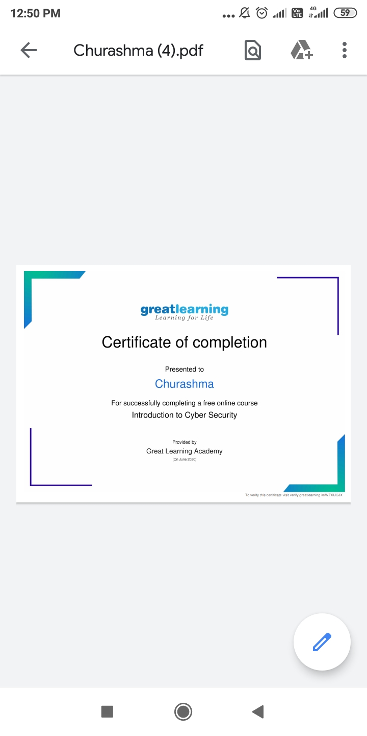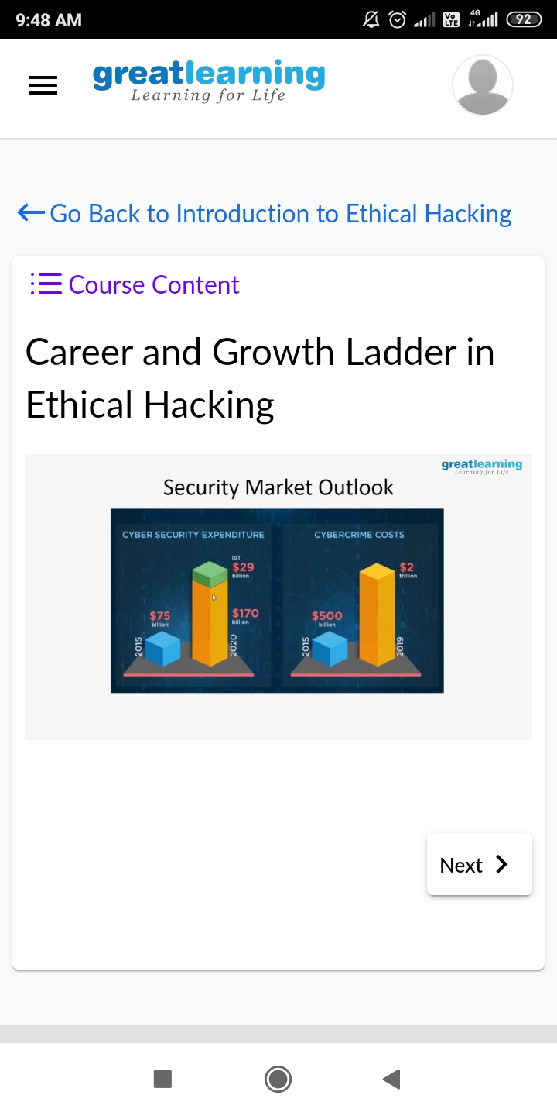

**CODING CHALLENGES DETAILS**:

**Problem statement 1:**  Write a C++ Program to swap two numbers using friend as a bridge concept.

